System Description

For

Lacy’s eStore

Document Version: [0.5]

Date: [04/05/2015]

Contents

1 Document Management 3
1.1 Contributors 3
1.2 Version Control 3
2 OVERVIEW 4
2.1 Service Description 4
2.2 Data Model 4
2.3 Reporting 4
2.4 Technology 4
2.5 Development Tools 5
2.6 Interfaces and services 5
2.7 Access, Authentication 5
2.8 Delivery 5
3 Support details 6
3.1 Third Party 6
3.2 Documentation 6
3.3 Standard tasks 6
3.4 Troubleshooting Guide 6
4 Related Projects or Major Support Work 7
5 Document Sign Off 7

Document Management

Contributors

Role | Name
Stakeholder | John Brown
Project Manager | Lee Bailey
Head Programmer | Shaidi Grell
Programmer | Lucas Moncada

OVERVIEW
An app to capitilize on the growing trend of purchasing things via mobile devices. It allows the user to easily browse the stores selection from the palm of their hand.

Service Description
- Display product information on their mobile app to promote new products and product specials.
- Create product groups to promote slower moving products with quicker moving products.
- Develop a feedback systems
- Develop product review system

Data Model
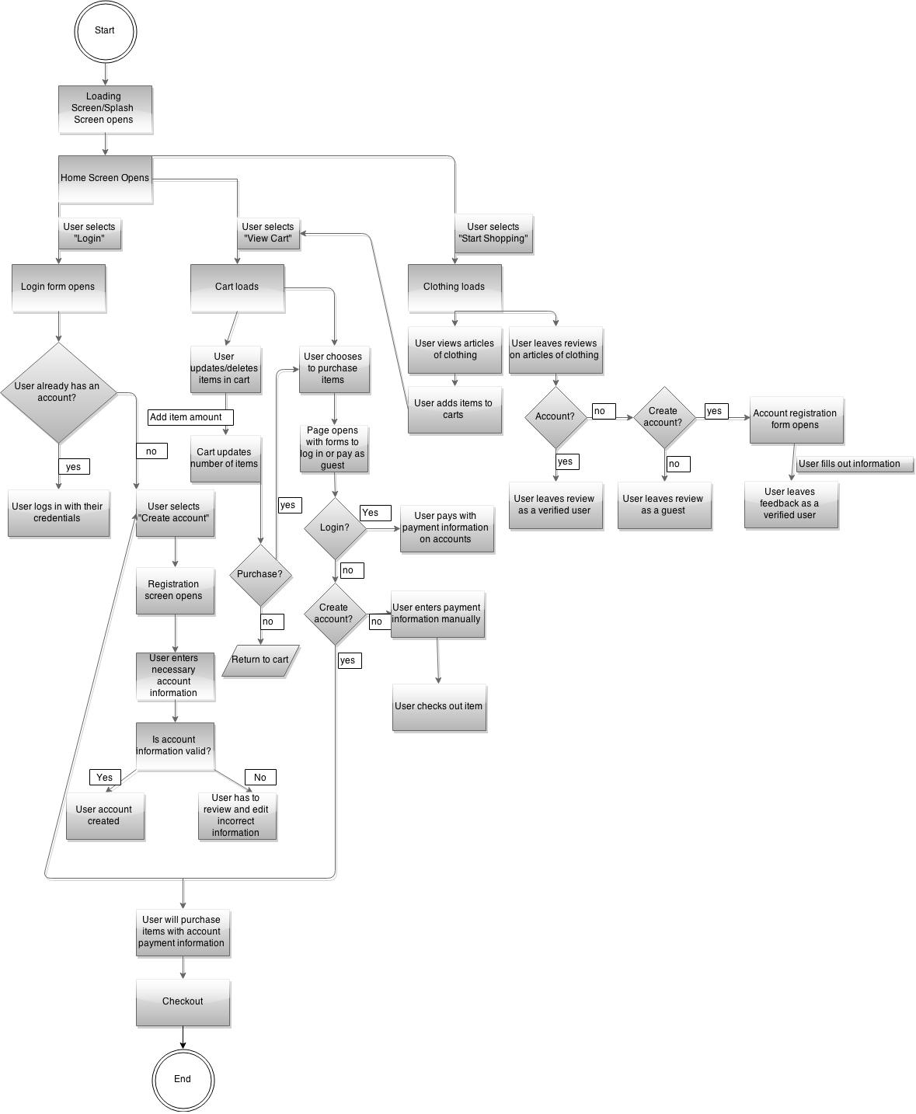

Technology
Sqlite database for data storage. Java runs the back of it on top of gui designs inside of android studio.

Development Tools
Android Studio
Distrubuted via github
Ran via android studio.

Access and Authentication
It's accessed via the android market place.

Client only requires having an android phone and the current required updates for the phone.

Delivery
The application is delivered via the android store.

Support details

Documentation

User Documentation
This user documentation will explain how the user interacts with the application created for Lacy’s store.
Log In
To log in the user have to have an account with the store. To do so, the user needs a username and a password. If the user doesn’t want to log in it can use the app as a guest.
Shopping
The user goes to the desire item to purchase and select the item. The item will be store in the shopping cart and ask the user if they want to continue shopping or to check out.
Create an account
To have an account the user needs to be a U.S resident and older than 18.
Log out
If the user has finished with application it can log out just going to the log out button that is shown in the application all the time.
Add items to cart
To add an item to the cart the user has to select the item, the item will be shown will the price information, sizes available and colors, and then the user can decide if it want to added to the cart or not.

Standard tasks

- Once the app is submitted to the android store, it'll be found via the keyword clothing & lacys.

Troubleshooting Guide

These pages should provided details of any advice that can be given to troubleshoot the service. The sort of questions that could be answered by the text in these pages include:

- Compatible with all android phones unless you're missing updates.
- Errors should pop up on the screen but are unlikely to happen.
- Just look for comments on the screens, previous issues and causes should be listed out there.
- No known issues yet but the program isn't finished.

Document Sign Off

Role | Name
Stakeholder | John Brown
Project Manager | Lee Bailey
Head Programmer | Shaidi Grell
Programmer | Lucas Moncada

